EC2 - Connect to Linux Instance
You can connect to your Linux/Ubuntu EC2 instance using the private key generated by AWS. To get started, start your instance and connect to it, as shown in the snapshot below.
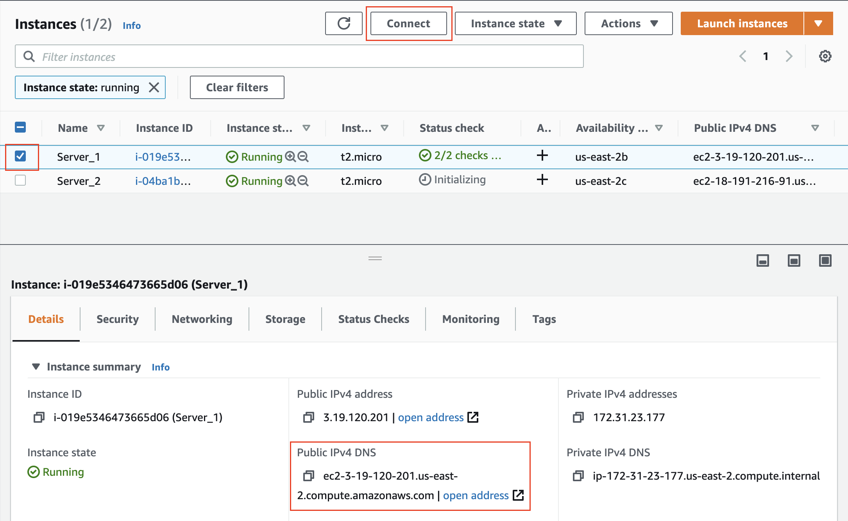
Connect to the selected instance. Note the public DNS.
AWS has launched the EC2 Instance Connect wizard, which can help you to connect directly from the EC2 dashboard. Alternatively, you can use SSH as well.
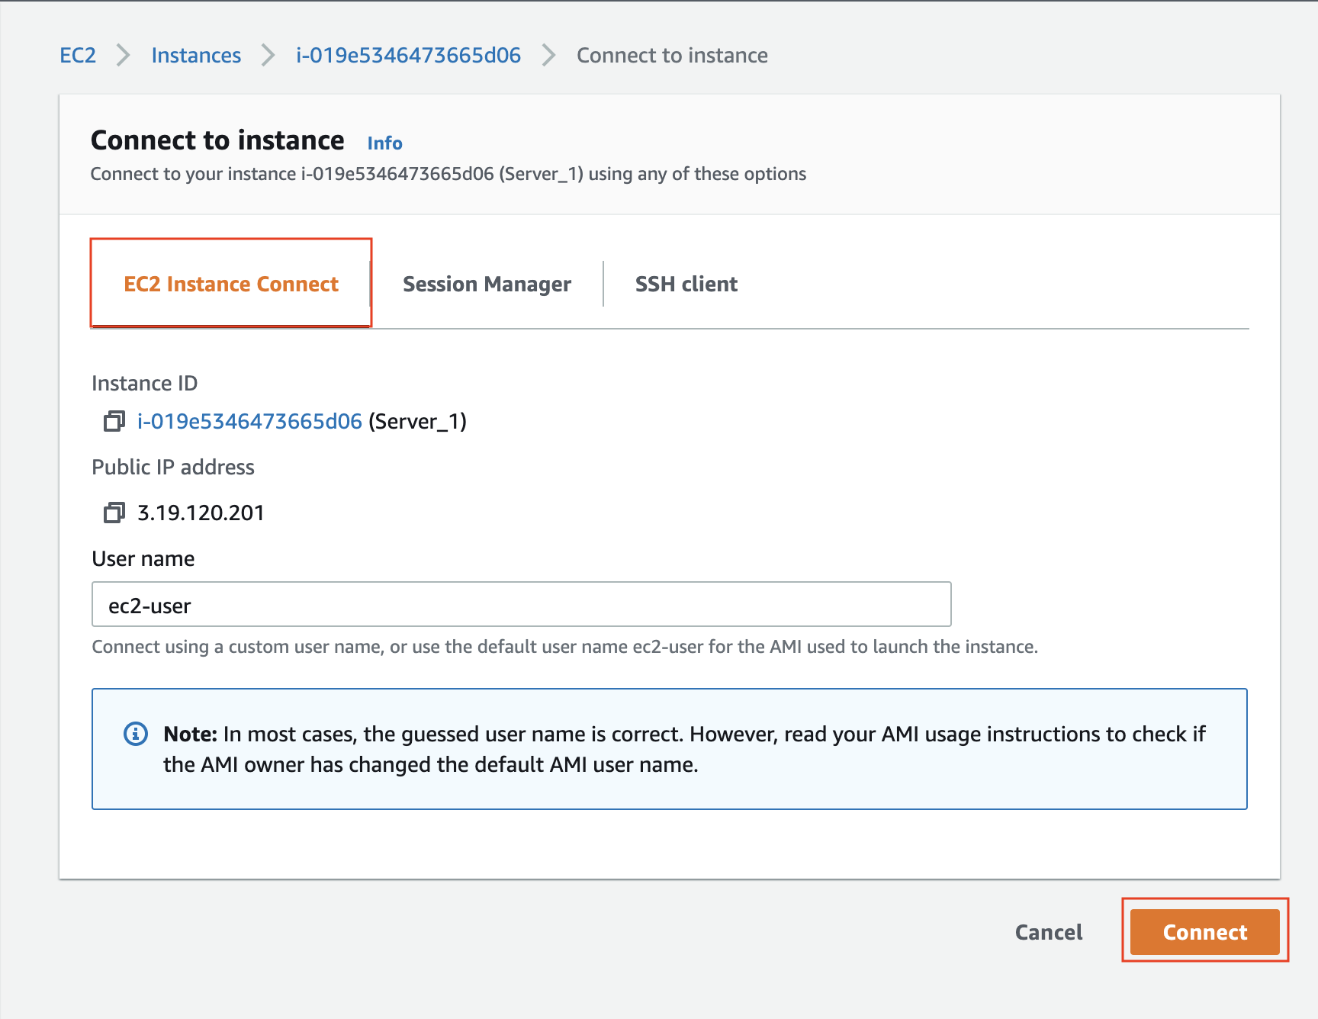
You can connect using the EC2 Instance Connect wizard.

Linux/Mac users
Linux/Mac users can log into your EC2 instance using Secure Shell (SSH) client. The following are the steps:
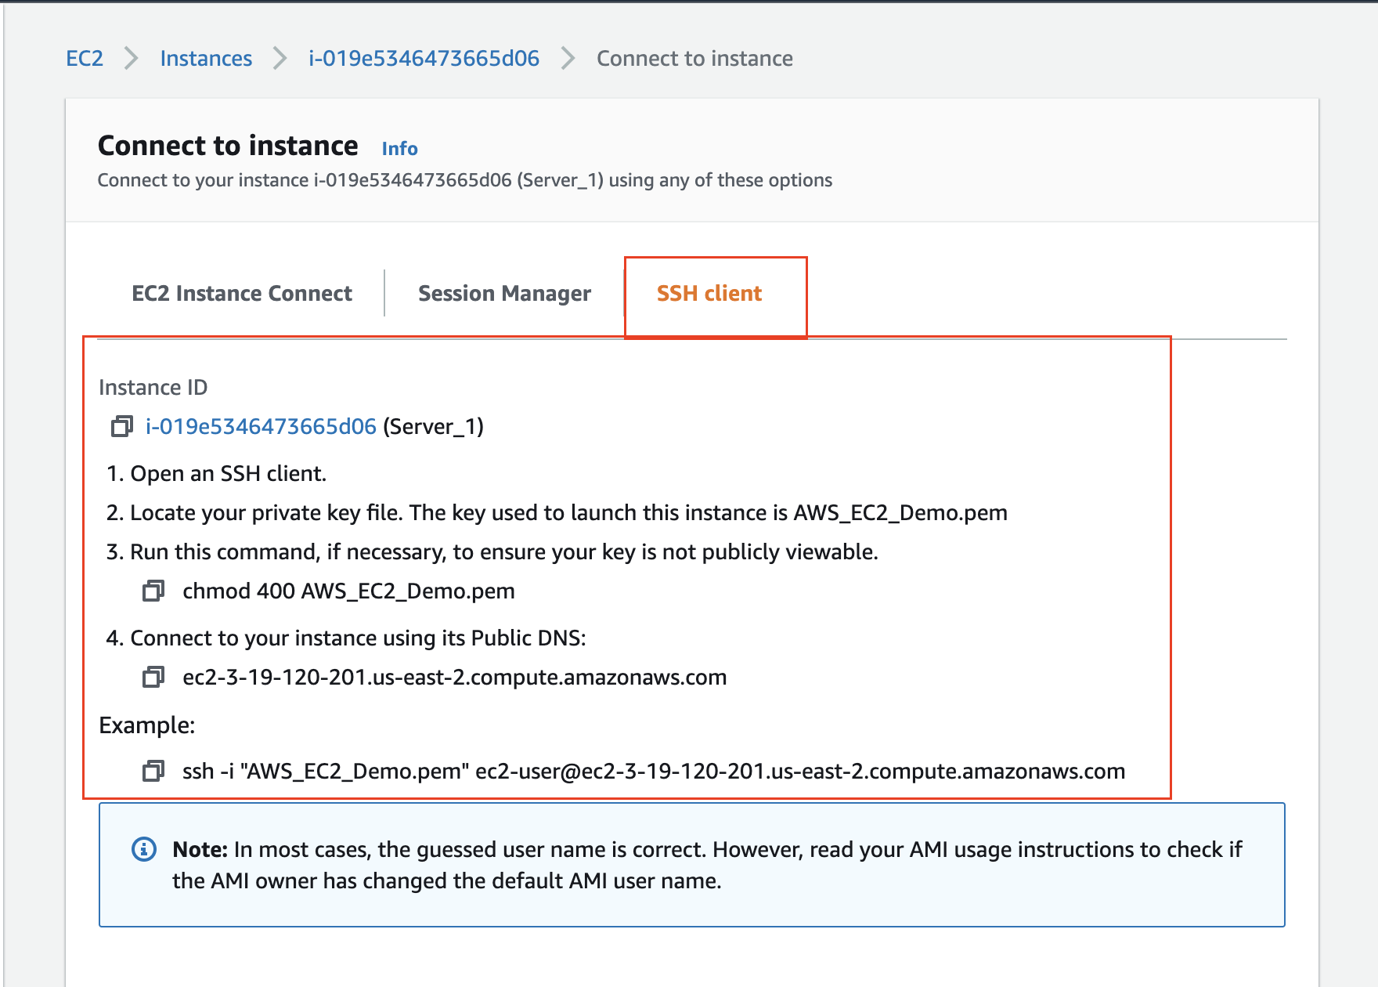
Connect using SSH. Copy the commands and follow the steps mentioned above.
- Change the Private key file permissions
Open an SSH client/terminal. Navigate to the directory where you have your private key (.pem) file in your local machine, and change the permissions to hide it from the public for SSH to work, using the command
- chmod 400 <path of private key .pem file locally>
- Connect using the Public DNS
You will log-in using the default name. The default username for Ubuntu instances is ubuntu, and for Linux, it is ec2-user. The list of default usernames is available here.
Connect to your instance using its public DNS, as
ssh -i <path of private key .pem file locally> <public DNS>
The successful login will show you a prompt as shown in the snapshot below:
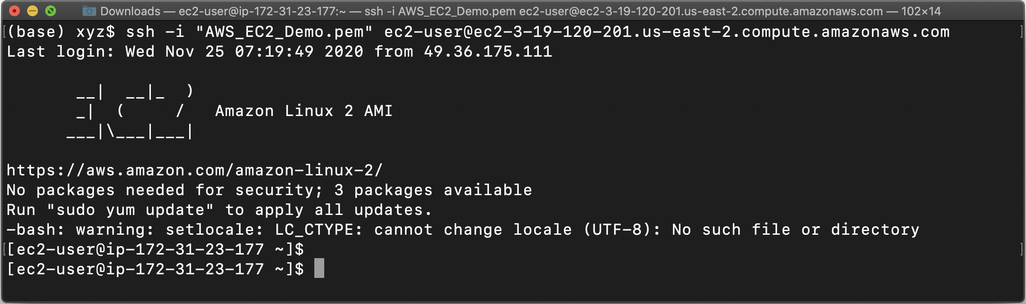
Successful login using SSH. Notice the private IPv4 address at the prompt is 172.31.23.177, which you can also see in your EC2 dashboard.

Windows users
Windows users can log in using PuTTY utility. The following are the steps:
- Download, and install the PuTTY utility suite in your Windows machine from https://www.chiark.greenend.org.uk/~sgtatham/putty/latest.html
- You will need to have your PuTTY Private Key (.ppk) file locally. For this reason, we will use PuTTYgen utility to convert the .pem file to .ppk format.
  - Run the PuTTYgen in your machine.
  - Click Load, as shown in the snapshot below.
  - Browse and load the .pem key into the PuTTYgen and then click on Save private key to save the key in .ppk format without a passphrase.
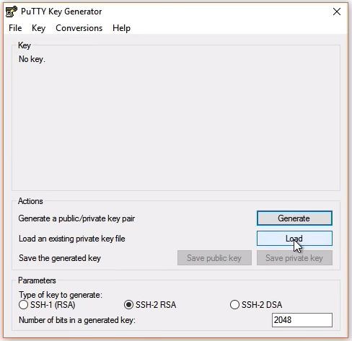
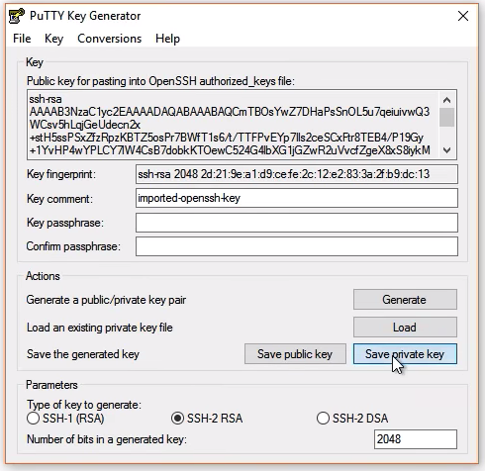
- Run the PuTTY to connect to the EC2 instance.
- Get the public DNS / IP address of your EC2 instance (host) from your AWS EC2 dashboard. Then, enter the public DNS / IP address of your EC2 instance (host) into the PuTTY . See snapshot below.
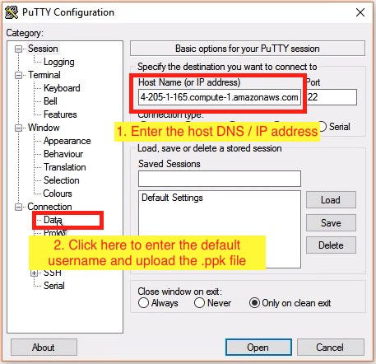
- Click on Connection → Data to enter the default username as ubuntu for Ubuntu, or ec2-user for Linux based OS.
- Click on Connection → SSH → Auth to upload the .ppk file. See the snapshot below:
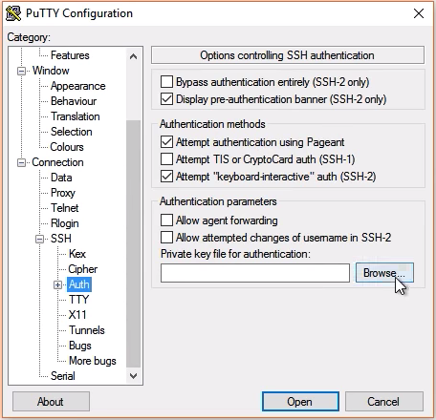
- If everything is set up correctly, a terminal window would open up to log you into your Linux/Ubuntu EC2 instance.

